Web Technology Lab 2025-26

Course Faculty: Prof. Dr. J Vimala Devi
Course Name & code: Web Technology Lab 22CSL35

Semester: 3rd 2025 Date: 18-12-2025

TITLE OF THE WORK | Design and Development of an Online Electronics E-Commerce Platform
STUDENT NAME | Nanjesh BR
USN | 1DS24CS128
ABSTRACT OF THE WORK | In the modern digital era, e-commerce platforms play a vital role in enabling users to purchase products online with ease and efficiency. This project focuses on the design and development of a responsive and attractive online electronics shopping platform inspired by popular e-commerce websites such as Amazon. The platform provides essential functionalities including user login, product browsing, brand showcase, shopping cart management, and real-time price calculation. The application is developed using core web technologies such as HTML, CSS, and JavaScript, without relying on server-side processing. The project demonstrates how front-end web technologies can be effectively used to build interactive and user-friendly business platforms suitable for real-world applications.
INTRODUCTION | In the modern digital era, e-commerce platforms play a vital role in enabling users to purchase products online with ease and efficiency. This project focuses on the design and development of a responsive and attractive online electronics shopping platform inspired by popular e-commerce websites such as Amazon. The platform provides essential functionalities including user login, product browsing, brand showcase, shopping cart management, and real-time price calculation. The application is developed using core web technologies such as HTML, CSS, and JavaScript, without relying on server-side processing. The project demonstrates how front-end web technologies can be effectively used to build interactive and user-friendly business platforms suitable for real-world applications.  The primary objective of this project is to create a user-friendly and visually appealing business platform that allows customers to browse electronic products effortlessly and manage their purchases effectively. The platform includes essential e-commerce features such as user authentication (login interface), product listing with images, brand showcases, detailed product information, and shopping cart functionality. Users can add or remove products from the cart, view selected items, and see real-time price updates, enhancing the overall shopping experience.  The application is developed entirely using front-end web technologies, namely HTML for structure, CSS for styling and layout, and JavaScript for interactivity and dynamic behavior. The design follows a responsive layout approach, ensuring compatibility across various devices such as desktops, tablets, and mobile phones. Grid-based product displays are used to present multiple brands and products in an organized and professional manner, similar to real-world e-commerce platforms  One of the key highlights of this project is the client-side shopping cart management system, which allows users to add, remove, and update product quantities without requiring server-side processing. JavaScript is used to handle cart logic, calculate total prices dynamically, and provide instant feedback to users. This demonstrates how powerful front-end technologies can be used to build interactive applications without backend integration.  Additionally, the platform includes an “About Us” section that describes the purpose of the website and the services offered, making it more realistic and business-oriented. Brand images and product visuals are incorporated to enhance user engagement and provide a professional appearance. The overall user interface is designed to be intuitive, simple, and visually attractive.

DESIGN | The design of the platform follows modern e-commerce UI principles:  - A clean and attractive landing interface  - Secure login interface for users  - Product cards displayed using a responsive grid layout  - High-quality product images sourced from the web  - Shopping cart section with add and remove functionality  - Brand showcase section displayed in a grid format  - Single clickable brand section linking to an external e-commerce website  The layout is responsive and adapts well to different screen sizes such as desktops, tablets, and mobile devices.
PLATFORM USED | The following tools and technologies were used in the development of this project:  - HTML5 – For structuring the web pages  - CSS3 – For styling, layout, and visual effects  - JavaScript – For dynamic behavior such as cart operations  - VS Code – Code editor for development  - Browser localStorage – To store cart items temporarily  - Netlify – For hosting and deploying the website
CODE LINK (GITHUB/ GOOGLE DRIVE) | LIVE WEBSITE URL :  CODE LINK :
CONCLUSION | The Online Electronics E-Commerce Platform successfully demonstrates the practical application of web technologies in building a functional and visually appealing business website. The project includes all essential features of a basic e-commerce system such as user login, product display, shopping cart management, brand showcase, and real-time price calculation. This project helped in gaining hands-on experience with HTML, CSS, and JavaScript and understanding the importance of UI/UX design in web development. The platform can be further enhanced by integrating backend services, databases, and online payment systems.
SCREENSHOT OF  THE BUSINESS PORTFOLIO | 1.Login Page  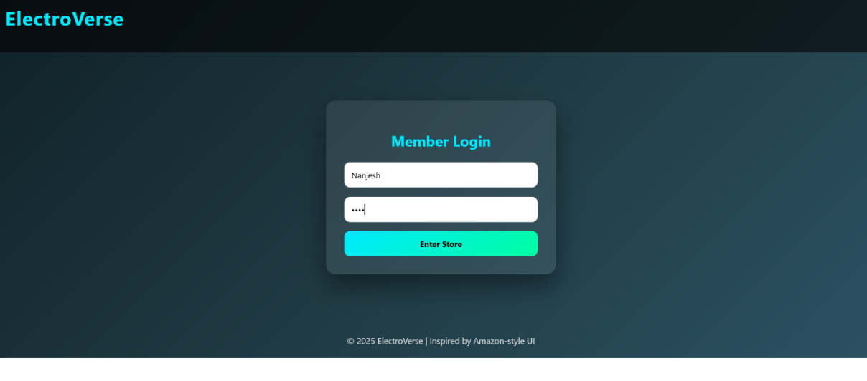  2.Home Page with Products:  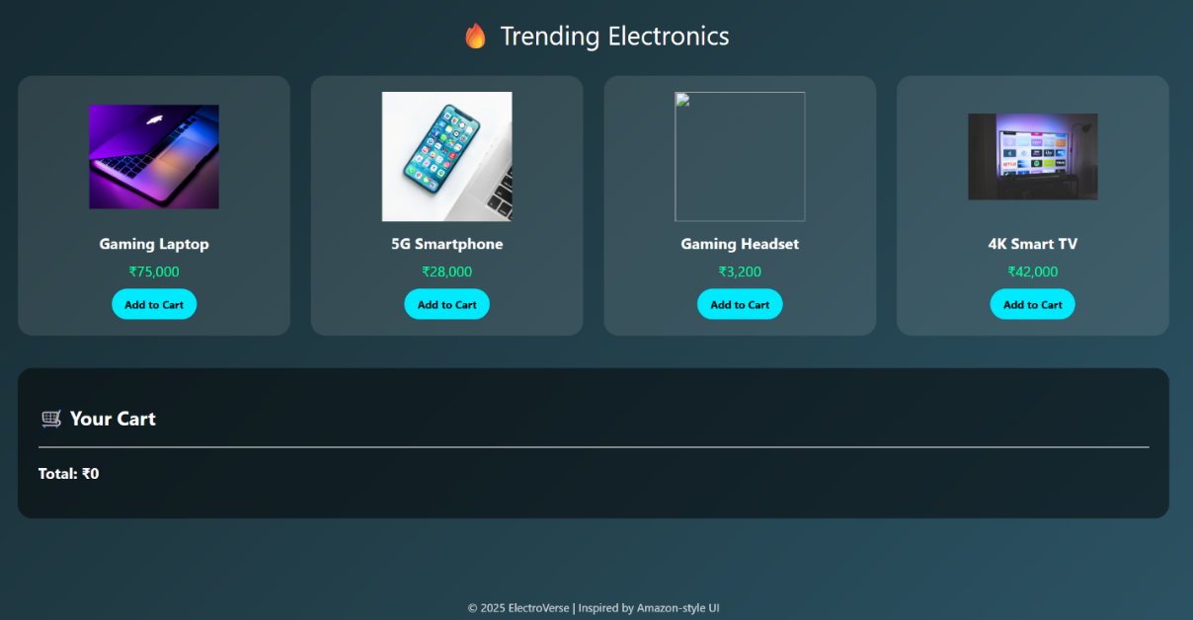  3.Shopping Cart Section    4. Brand Showcase Section  